software applications- AR (Augmented Reality)

Augmented reality (AR) apps are software applications that integrate digital content into the user's real-world environment. AR apps can include visual, audio, and other sensory elements and use a device's camera and sensors to determine where the user is and what to display. AR apps are written in special 3D programs that tie animation or contextual digital information to an augmented reality marker in the real world.
AR apps can be used in many industries, some examples of AR apps are Pokémon Go, TikTok and Snapchat filters, and AR Zone app. In manufacturing and industrial settings, glasses or headsets can be better gateways to the AR experience than mobile devices, as they allow the user to have their hands free. Healthcare, Public safety, Gas and oil, Tourism, Marketing, Gaming, Product visualization, Architecture and home design, Education, and Industrial manufacturing. AR delivers visual elements, sound and other sensory information to the user through a device like a smartphone, glasses or a headset. This information is overlaid onto the device to create an interwoven and immersive experience where digital information alters the user's perception of the physical world. The overlaid information can be added to an environment or mask part of the natural environment. Augmented reality has a variety of uses, from assisting in the decision-making process to entertainment. AR is used to either visually change natural environments in some way or to provide additional information to users. The primary benefit of AR is that it manages to blend digital and three-dimensional (3D) components with an individual's perception of the real world.
In this project I mainly focused on the use of Augmented Reality Marketing in Business. Augmented reality layers computer-generated components onto your physical surroundings. In simple terms, augmented reality is a digitally enhanced version of the physical world. The augmented reality is achieved through sound, superimposed computer-generated images, and other sensory elements. Consumers access these experiences through augmented reality software by using a compatible mobile device. Augmented reality is highly interactive, meaning that once a user opens their mobile device, they’re in the driver’s seat of their augmented reality experience. This may mean walking in a physical space to interact with populated content or responding to options or commands within the augmented reality experience.
Augmented reality simple tasks such as regularly updating customer records, or making sure invoices are created, sent, and chased in line with customer statement of works, are an easy way to sharpen the approach. In an increasingly complex environment, companies must become more agile and gain more control over their AR to adapt successfully to margin pressures and rising costs. If you are in procurement, finance or treasury this white paper provides practical guidance on how a true sale, off-balance sheet accounts receivable financing solution can combat the effects of inflation on receivables and guard against the impact of an economic downturn. Advance technology’s increasingly useful role in fully optimizing AR function and AR processes can play an important role in managing businesses through this difficult period. For example, Since 2011, INDE's augmented reality studio has developed award-winning AR experiences for a huge variety of clients including Major League U.S. Sports Brands and Premier League Soccer Clubs, alongside working with the largest retail companies and brands in North America and Worldwide.
Augmented Reality is an interactive tool enabling brands to create fantastic content. Brands already recognizing the power of Augmented Reality marketing have used AR successfully in their marketing campaigns getting greater visibility, having more fun, and enjoying revenue growth as a result. Find out what Augmented Reality marketing is, how it works, which well-known brands have used Augmented Reality for marketing—and how—plus examples of their successful AR campaigns.

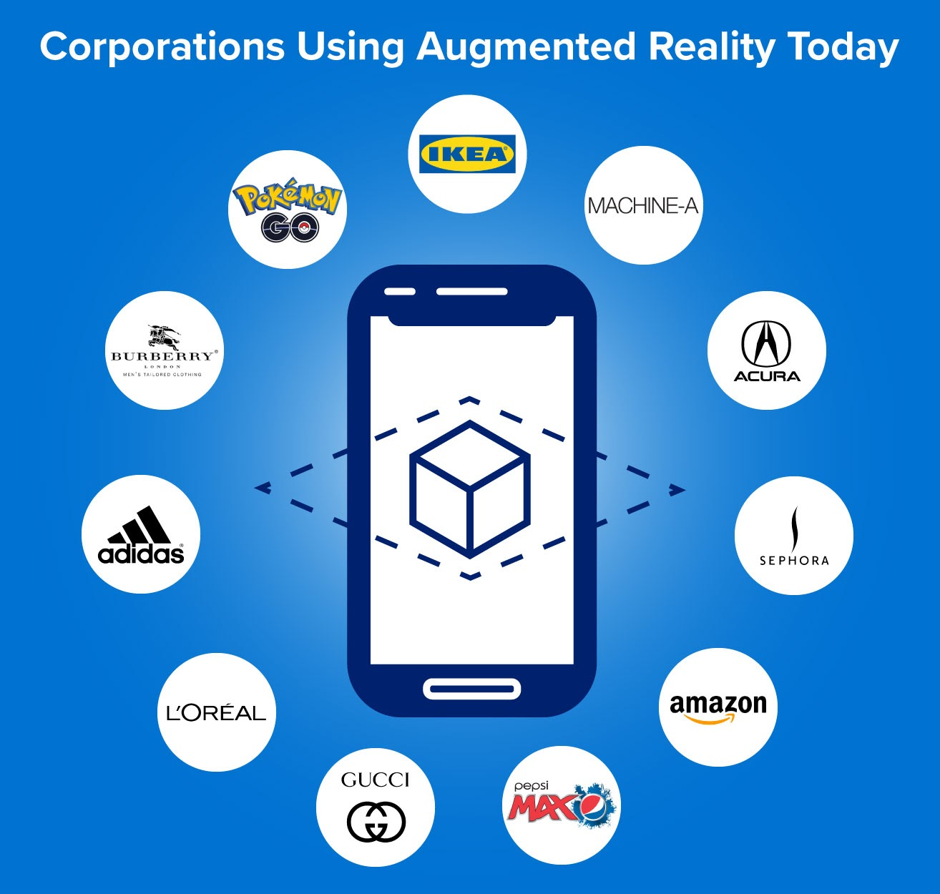
With the right digital marketing strategy, your brand can use augmented reality to help drive purchases, increase purchase satisfaction, improve brand awareness, decrease returns, and even shift brand perception.
AR agency that’s not only satisfied with simply designing and developing three-dimensional content for our AR platforms, but also able to organise live production shoots - in AR-ready green screen or using volumetric capture - for original content with talent in any location Worldwide. Augmented reality agency team has assured its installation capability anywhere in the world, and in so doing, has become the trusted name in event-based and permanent AR production globally, with deployments to almost 50 countries.
AR in marketing to improve customer engagement and experience, augmented reality (AR) in marketing involves employing digital technology to overlay virtual items or information over the virtual environment.
The concept of AR Augmented reality (AR) is a technology which enhances view and makes interaction with the environment by superimposing computer-generated visuals. That information will present in the real-world environment.
AR in a business-to-business setting, augmented reality, or AR, integrates interactive digital information and images to improve real-world experiences. It can enhance training, remote collaboration, and sales and marketing, among other applications. Several augmented reality marketing types include marker-based, markerless, projection-based, and superimposition-based augmentation. Each type employs various strategies for consumers to produce immersive and interactive experiences.
Augmented reality (AR) in advertising enables the creation of interactive experiences that let customers imagine things in their environments, try on virtual outfits or cosmetics, and discover product characteristics more interestingly and memorably. AR affect marketing by enabling customers to engage with products more immersivity, augmented reality (AR) can change marketing. It improves product visibility, fosters consumer interaction, and raises conversion rates. Also, AR offers useful information for targeted advertising.
Augmented Reality (AR) marketing sets a new trend for brands to communicate with their audience via their mobile app using interactive content. AR technology made it possible to visualize myriad types of digital content, thus easily accessing missing information about product’s size, shape and/or features. AR apps enable users to interact with products: to reach out and “touch”, view from different angles, take snapshots, and much more. Due to the still-relative novelty, a combination of these features enables creating a “wow! Effect” leaving a lasting impression so users remember the product and its manufacturer. Still, we believe AR will remain engaging even when it becomes mainstream because it allows us to see a world beyond our world. Here is how an AR app works: using a smartphone camera, point at a marker or get an event activated based on smartphone’s GPS coordinates and see different types of information displayed on the smartphone screen. This might be 3D models, overlaid pictures, videos, text descriptions, mini-games—almost everything!

Due to the technological advancement in AR engines, it is easier to produce apps for mass consumers and deliver them via app stores. Users only need a smartphone with a launched app and voilà, previously invisible objects are present and interactive. Augmented Reality is great fun, but also useful. Both suit marketing purposes. AR apps can be used for product promotion.Via an app, manufacturers can demonstrate their products’ actual sizes and dimensions, available colours, combinations with other products, display prices and discounts. AR apps can educate their users by visualizing product features, benefits, use cases, assembly instructions, and suggest recommendations—plus much more. If you can imagine it, AR can do it.
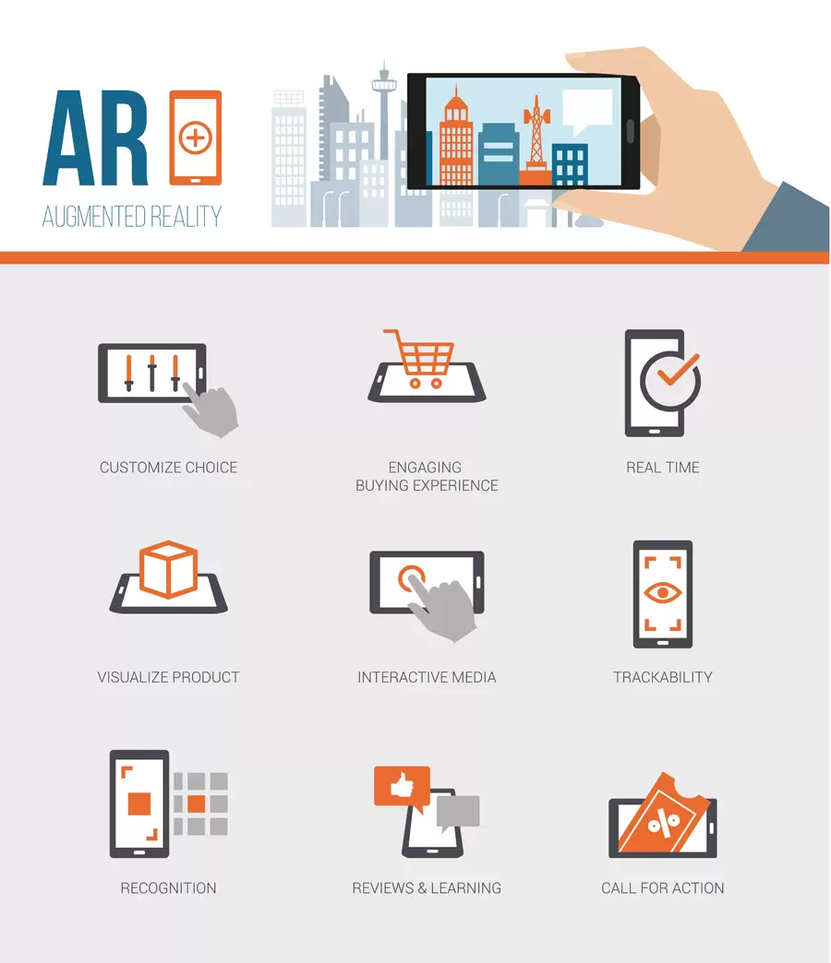
AR apps can be used to create advantages for a product.

AR apps enable not just finding any product information but making it possible to try a product when and where users want it, then purchase what they like, thus saving time on visits to brick and mortar stores.

Users can do the following via AR apps, what is inside the packing box try new products virtually, looking at them at all angles compare assorted colours and models of an item to decide which suits better order products via the app. Therefore, implementing Augmented Reality in an ecommerce app significantly improves user experience by raising the degree of users’ awareness and helping them buy what they want within one digital solution.
In conclusion, the marketing sector has already seen major advancements in augmented reality (AR), which offers creative and compelling ways for firms to engage with customers. Augmented reality (AR) has the potential to play a significant role in the future of marketing, given its capacity to produce immersive experiences.

